Social Implicatiopns: Green computing
si_green_computing.php — Social Implications

Green Computing and E-Waste

Be a Superhero - Save Our Planet!

It may be hard to accept that ICT and computers are an environmental problem. After all computers don't produce pollution like cars do. They don't use water. All they do is use a (relatively) small amount of electricity…
The fact is that ICT and computing has a greater environmental impact than you think!
The three main areas of impact are:
Mining and Manufacturing

The electronics in IT devices needs normal materials such as copper, steel, magnesium and aluminium - as well as rare minerals (how rare? they are actually called, as a group, Rare Earth Minerals) for their manufacture. All these raw materials need large mining operations to produce. Gadgets also need plastics (manufactured from oil) and glass. Both of these components use large amounts of energy in their production.
The raw materials need to make multiple trips around the world - from source to refinement to manufacturing and then to the markets for the final products. This transportation uses up huge amounts of fuel and dumps large amounts of carbon into the atmosphere.
The mining of resources, transportation of resources and final products and the manufacturing process consume large amounts of power and generate large amounts of pollution.
I'd call that an environmental impact…

How can YOU help?
Think before you buy!
Ask yourself: "Self: Do I really need that new device / gadget? Is my old one still working OK? What do I need the new one for?"
If your upgrade is really a 'boastgrade' or 'statusgrade' rather than something that you really need that will bring value to your life…. well, why not rethink?
Each year you hold on to your old device instead of buying the latest thing new toy is a year that you are helping the planet out!
Return to the top of this panel
Power Use
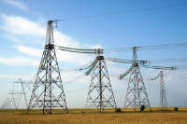
When it comes to thinking about ICT and power you have to think far bigger than your own personal devices at home.
ICT uses huge amounts of power.
The Data Centers needed to power our online, connected lifestyles use up more electricity than you can imagine.
Much of this power is generated using fossil fuels (coal, gas, diesel) which dump large amounts of carbon into the atmosphere and so is a major contribution to the problem of Climate Change.
This quote from Forbes helps to put the size of the problem in context….
U.S. data centers use more than 90 billion kilowatt-hours of electricity a year, requiring roughly 34 giant (500-megawatt) coal-powered plants.
Global data centers used roughly 416 terawatts (4.16 x 1014 watts) (or about 3% of the total electricity) last year, nearly 40% more than the entire United Kingdom.
And this consumption will double every four years.
Radoslav Danilak - Forbes
Published Dec 15 2017


Solutions
Part of the solution has to be developing more power efficient computing
Part of the solution is to use more environmentally friendly renewable energy sources such as Solar power and Wind power instead of fossil fuels.

Vampire Power
You also contribute to the power problem - mainly because you keep vampires in your house.
These vampires don't drink blood - but they love electricity!
Your TV / DSTV decoder that's on standby, your microwave with its clock, your smartphone charger that you leave plugged in all day…
All these devices appear to be off - but in reality they are continually using power… sucking electricity from the grid….

What you can do…
Make sure your devices are unplugged from the socket when you are not using them - it is not only good for the environment but will save you money (and help prevent load-shedding!).

Return to the top of this panel
E Waste
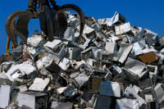
E Waste.
Every year thousands of tons of devices (not just computers and smartphones but fridges, washing machines, microwaves, batteries, etc.) get dumped.
Many of these devices contain toxic chemicals that can leach into the soil and contaminate ground water (and therefore drinking water / crops).
Many devices contain rare and valuable minerals that have to be replaced by mining more of the same at great cost, use of power and pollution generation.
Most devices are not biodegradable and so will end up taking up space in landfills and leeching out their poisons for many tears to come.

Recycle, Re-use
Don't just dump your old device (or leave it in a drawer somewhere).
If it still works and can be used give it to someone who can use it (or to a charity shop which can use the money from selling it at a reasonable price).
If it is not working, recycle it.
The graph below shows just how much material could be recovered if we recycled our devices instead of dumping them!
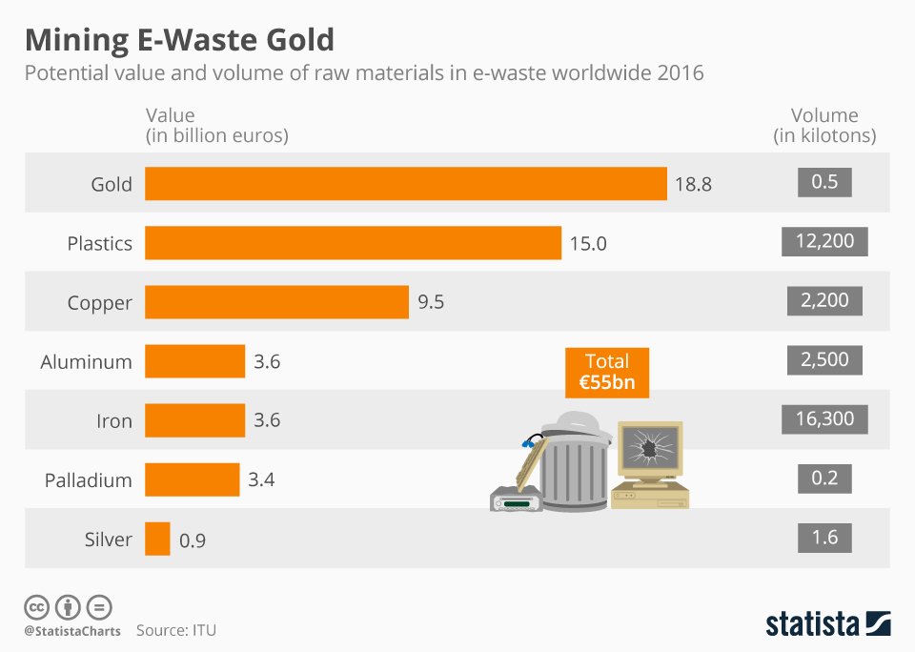
Graph from Statista.com - used under CC license.
Return to the top of this panel

Video Links - Green Computing & E Waste
We have selected and curated a set of videos on YouTube related to your course.
These videos are not created or owned by us.
They may display advertising and in some cases may contain limited amounts of swearing.

Notes for this Module
What to look out for and do in this module...
The FAQs are not questions that are likely to appear in exam papers - they are real questions that most people ask about the content.

FAQs for this module
Questions on Green Computing and E Waste - and their answers...

Network Types FAQ
View the questions or type in the term you are looking for below…
No results were found

How can I be greener in my use of ICT?
Don't buy new kit every year.
Unplug (don't just switch off) your devices when you are not using them.
Recycle or reuse old devices rather than dumping them in the trash.

